**TempPulseBee**

**EL428 Project**

**Prepared by Group 1**

**Submitted to: Submitted by:**

**Prof. Amit Sengupta Brijesh Kumar : 201101102**

**Prof. Asim Banerjee Nikhilesh Somani : 201101200**

**Nirav Devpura : 201101210**

**Maulik Lalani : 201101222**

**Vijay Khitoliya : 201101225**

**Rakesh Rajak : 201101236**

**Problem Identification**

Last semester, during one of the courses named SPI some of our group members conducted survey in rural areas to find out about the the state of health centres and hospitals. They visited various villages including Dholakuva, Shahpur, and Ratanpur and interviewed many doctors and patients present there to find out more about the problems faced by them. Listed below are some of the problems :

* Unavailability of Doctors and Nurses : Due to not so high wages, there is always a shortage of staff and thus same doctors were assigned jobs at different health centres not allowing them to spend enough time at each centre.
* Major Diseases : Some of the major diseases through which most of the villagers are suffering are Malaria, Viral fever, Heat Stroke.
* Shortage of medicines - Also at some of the health centres, there was a shortage of necessary medicines making things worse for patients.
* Equipments not in the best condition : Also, at some of the health centres important and necessary equipments were not present in their best of working condition.

**Solution**

We identified Problem No.1 and No.2 as our primary problem, and TempPulseBee tries to solves the very same problem. As we know that there is problem of same doctor working at more than one centre, we tried to solve the problem using ICT. Temperature and Pulse Rate are two major deciding factors in any of the above mentioned diseases. So any major change in any of the above factors would communicate the doctor/nurse that there is a change in condition of patient.

**Features**

* Monitors Pulse Rate of a group of patients.
* Monitors Temperature of a group of patients.
* Displays any of the above on the display screen through Xbee, if they go above the mentioned threshold.
* Also with peltier, we could control the temperature of body temporarily.

#### 

#### **PULSE RATE AND BODY TEMPERATURE MONITORING DEVICE**

#### **AND**

#### **TRANSMITTING THEIR RESPECTIVE VALUES USING XBEE**

#### 

**Introduction**

Health is the general condition of a person in all aspects. It is also a level of functional and metabolic efficiency of an organism, often implicitly human. The state of health of a population is a direct determinant of its development. It affects productivity, the potential of children, infant and general mortality, and the allocation of resources within a family, community and nation. Access to better health services helps in poverty reduction and increased productivity, therefore, investment in health is a prerequisite to economic and social progress.

The development in bio-medical electronics led us to propose the design of the “Pulse Rate and Body Temperature Monitoring Device and transmitting their respective values using XBee”. This project is mainly concerned with creating a portable device that will monitor human pulse rate and body temperature.

**Conceptual Framework**

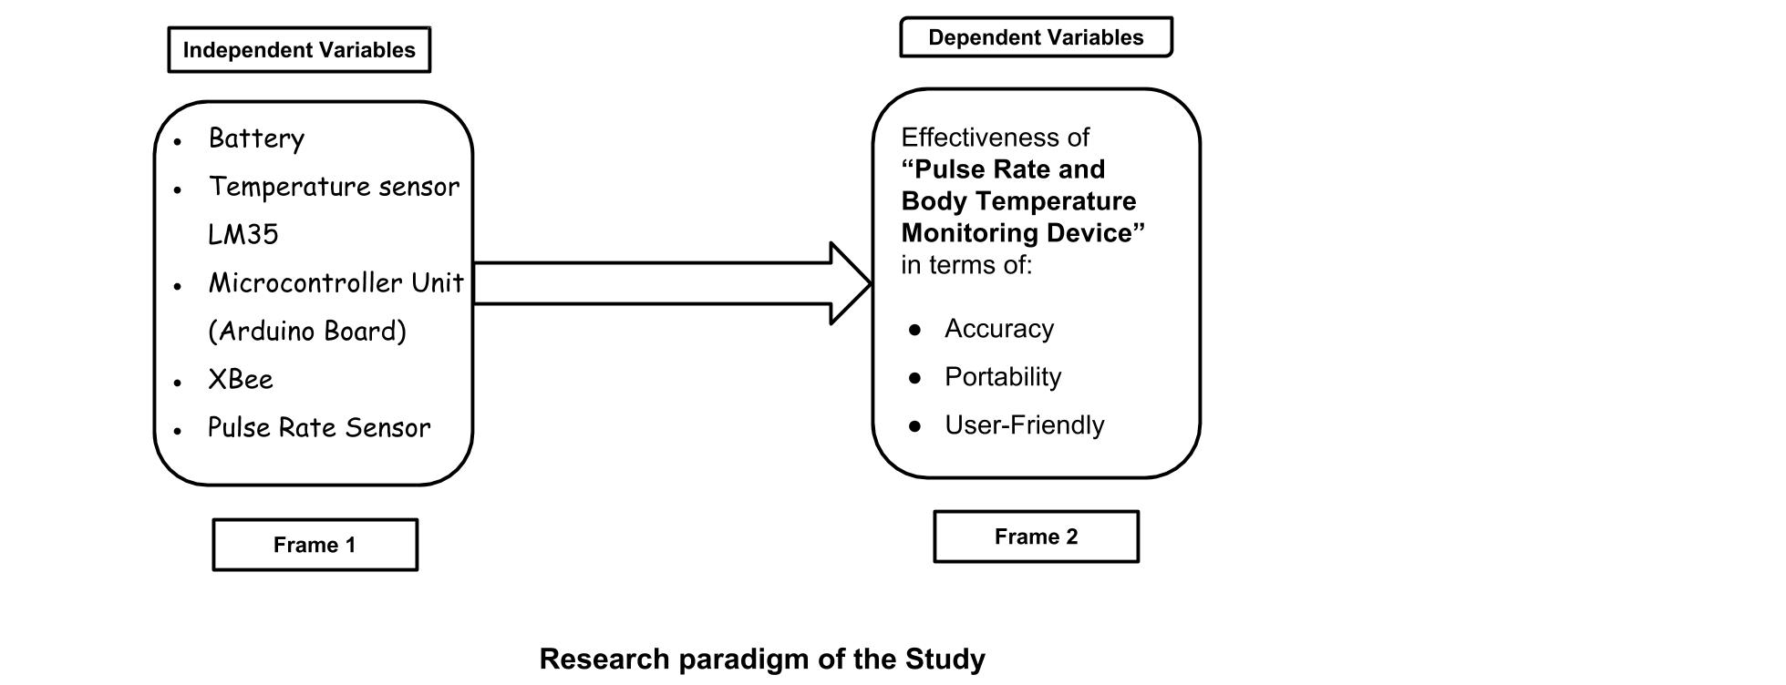

**Statement of the Problem**

The study aims to create a working prototype of the “Pulse Rate and Body Temperature Monitoring Device” and will also be used as an additional device in hospitals and health care centers of rural areas. It intends to answer the following problems:

* What is the design of the “Pulse Rate and Body Temperature Monitoring Device” that will be used as an alternative to the conventional type of pulse oximeter (device that measures pulse rate) and thermometer used in hospitals and health care centers of rural areas ?
* How will the principles of electronics be applied in biomedical technology?
* What is the level of effectiveness of the “Pulse Rate and Body Temperature Monitoring Device” in terms of accuracy, portability and user friendliness?

**Significance of the Study**

The project was conducted and designed to benefit the following:

* Hospitals and Health Care Centers in rural areas

The study will help Hospitals and Health Care Centers in rural areas in using the “Pulse Rate and Body Temperature Monitoring Device” as an alternative to the conventional type of pulse rate monitor and thermometer.

* Future Researchers:

It will provide the future researchers an additional knowledge and concept from the project and may serve as a basis and pattern for any advanced prototype they may want to develop considering this.

**Research Methodology**

**1. Research Design**

The experimental method will be used to complete this study. This method is a highly controlled procedure in which the manipulated actions from a factor or condition, called the independent variable are applied upon another factor, called the dependent variable in order to determine the effect of the former to the latter. The researchers will follow this method of experimenting and prototyping since they will be constructing a functional prototype.

The “Pulse Rate and Body Temperature Monitoring Device” is under the experimental method because it will be conducted considering proper experimental design. The members of the group gave their full effort in organizing the gathered data needed to accomplish this study.

**2. Data Gathering Procedure**

This includes the supplies and materials, tools and equipments, construction procedure, construction time frame, block diagram, flow chart, schematic diagrams, estimated cost of production and the research instrument that will be used to enlighten the readers on the processes essential to the construction of the “Pulse Rate and Body Temperature Monitoring Device”.

**3. Construction Procedure**

* Conceptualization the design of the project
* Preparation, canvassing and purchasing of supplies, materials, tools and equipments.
* Construction of the circuit diagrams and assembly of the device
* Programming
* Try-outs and revisions
* Finalization and completion of the project
* Evaluation of the product’s operation

**Try-outs and Revision**

|  |  |  |  |
| --- | --- | --- | --- |
| **Trial** | **Situation** | **Outcome** | **Revision** |
| 1. | When clipping the pulse rate sensor to fingertip, the sensor takes a hard time to detect the pulse point to the user. | The sensor cannot get the accurate pulse per minute. | Its still under process, |
| 2. | Measuring pulse rate and body temperature | The result is adequate for the device. | No need to revise. |
| 3. | Transmitting pulse rate and body temperature using Xbee | Proper transmission is taking place. | No need to revise. |

**Block Diagrams**

**1. Pulse rate transmission using XBee over Arduino**

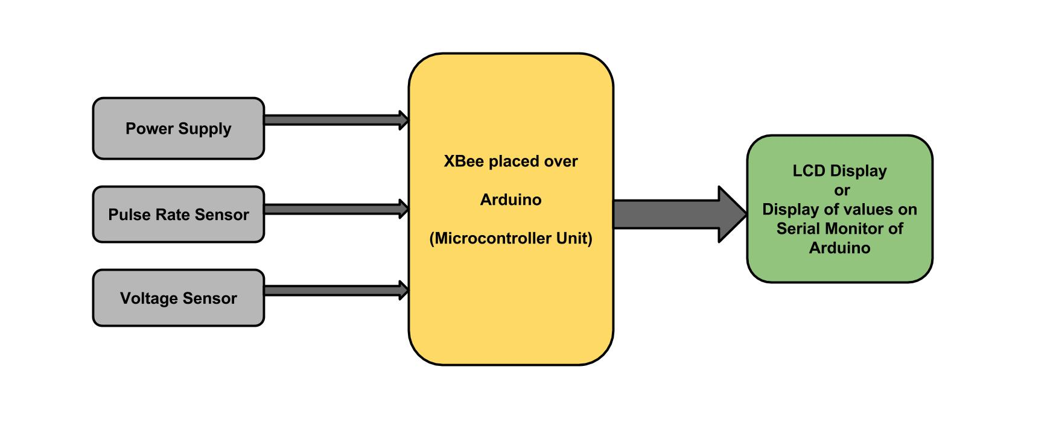

**2. Temperature value transmission using Xbee over Arduino**

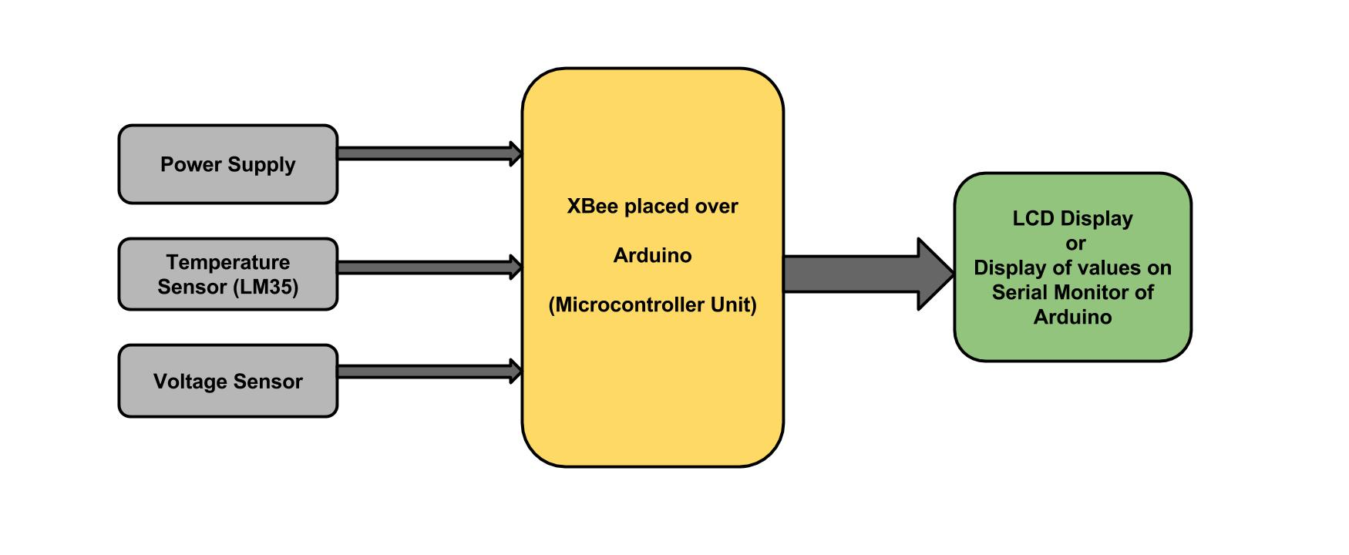

**Conclusion**

Based on the findings of the project, the following conclusions were drawn:

* The design of the Pulse Rate and Body Temperature Monitoring Device consist of the appropriate materials namely: Liquid Crystal Display, Pulse Rate Sensor, Temperature Sensor and Assembly Language Program.
* The principle of electronics was applied to this study by combining the application of engineering and technology to the domain of biomedical system.
* The study was able to determine the level of functionality of the Pulse Rate and Body Temperature Monitoring Device in terms of accuracy, portability and being user-friendly it has been interpreted as highly functional thus providing the same accurate results as to the conventional method of reading pulse rate and body temperature.

**Recommendation**

For the enhancement of the designed project, the following are recommended:

* To change the appearance of the device for the sake of the patient / user to avoid anxiety.
* By adding a switch to start or stop the count of the pulse rate sensor so it will not automatically count when the device is turned on.
* It is recommended to reduce the size of the device to much portable and easy to carry.

**Pulse Rate Monitoring Using Arduino**

**Introduction**

Pulse rate modulator works on simple idea of transmitter and receiver. In our project we have used IR LED emitter and detector. We are measuring the pulse through the finger tip where the blood pressure varies depending on different conditions. The output of our project is very much affected by the surrounding noise.

**Project Requirements**

**Parts:**

* Carbon film resistors
* 470K, 68K (2), 39K, 8.2K, 1.8K, 1K, 220Ω
* Infrared LED Emitter and Detector
* Arduino Uno
* NPN Small Signal Transistor, 2N3904
* 1.0 μF Tantalum Capacitor
* Jumbo Adhesive-Backed Cable Clip
* M324 Quad Op Amp , 14-pin DIP
* 24AWG 4 Solid Conductor Intercom Wire
* Multipurpose PC Board with 417 Holes
* 0.1μF Ceramic Disc Capacitor (2)
* SB A/B cable

**Circuit Designing:**

**Schematic1:**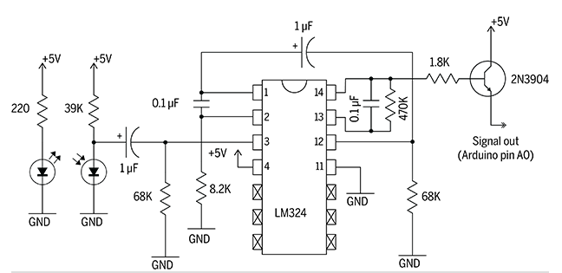

**Working:**

The sensor itself consists of an infrared emitter and detector mounted side-by-side and pressed closely against the skin. When the heart pumps, blood pressure rises sharply and so does the amount of infrared light from the emitter that gets reflected back to the detector. The detector passes more current when it receives more light, which in turn causes a voltage drop to enter the amplifier circuitry. After that, we have two operational amplifier enclosed in a IC 324 which amplifies and filter out the noise. Finally we have Transistor 2N3904 which amplifies the signal and gives output. The output that we got is then passed through arduino analog pin A0 and graph is displayed on the screen which shows the pulse rate variation.

**Testing**

For testing, we are giving 5V power supply to the circuit and also to the IC. Because of surrounding noise, we are not getting the correct output. IR detector is detecting the signals properly but the voltage is very low and hence passed through operational amplifier and then to transistor.

**XBee Wireless** 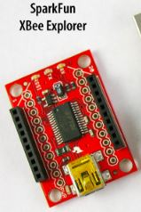

**Introduction**

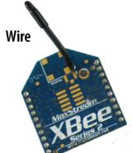

Wireless Sensor Network ( WSN ) provide a simple, economic approach for the deployment of distributed monitor and control devices.

In our project we used the standard XB24-B to establish the connection between end node and base station. Patient data will be collected by arduino boards will be processed and transmitted by these board.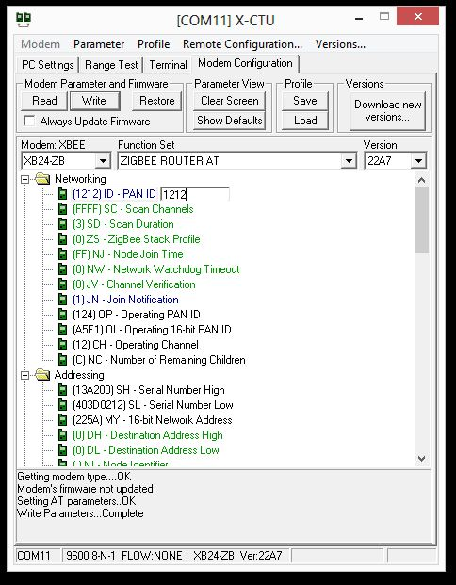

To configure the XB24-B we used SparkFun development board. Pin 3 in xbee is configured to monitor the Temperature sensor . further X-CTU is used to define the PAN ( Personal Area Network ) coordinator in xbee network , by using this all patient of one category like E.N.T. can be assigned with unique PAN ID with single PAN coordinator.

**Simulation**

In matlab simulation we created three condition in which data at each node are generated at i). 50 Kbps ii). 200 Kbps iii). 2Mbps. then created a graph of throughput vs number of nodes. Throughout defines the rate at which data is transmitted between two nodes. In simulation we find out that as the number of nodes( patient ) in one personal area network increases the throughput will decrease, due to congestion. Since network topology is using TCP packets, for every lost packet new packet is generated and retransmitted .

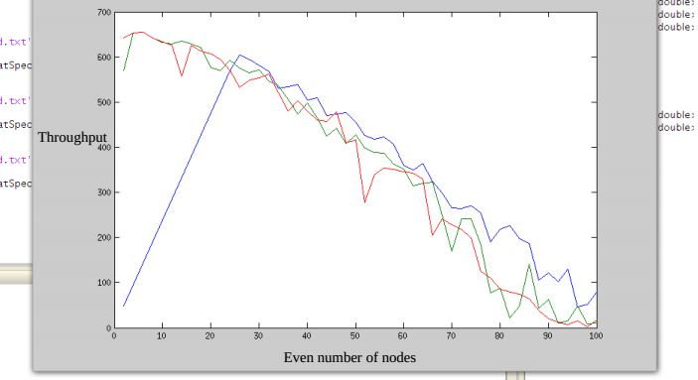

**Human Body and Temperature**

As part of project work, measuring and controlling the body temperature, first we need to do some research on Human body temperature. Human body has the excellent capacity to maintain and control our body temperature. Even if the surrounding temperature goes below 10 degree Celsius or it rises above 45 degree Celsius, our body maintains its core temperature.

Humans are homeotherms. Normally, the human body maintains an average core temperature of 37±0.5 degrees Celsius, or 98.2±1.3°F. The core temperature varies slightly due to environmental and metabolic factors. Exercise or fever may raise core temperature up to 3°C , while exposure to cold may lower by one degree. Beyond these boundaries, the human is susceptible to heat stroke or hypothermia, both of which are in a life threatening conditions.

The temperature of the human body is regulated by neural feedback mechanisms which operate primarily through the “hypothalamus”, under control of the mechanisms, sweating begins almost precisely at a skin temperature of 37°C and increases rapidly as skin temperature rises above this value; oppositely, if the skin temperature drops below 37°C, a variety of responses are initiated to conserve the heat in the body and to increase heat production, these include vasoconstriction, cessation of sweating, muscular activities, shivering, etc.

**Body’s Mode Of Heat Transfer**

* Conduction : Conduction is heat transfer by means of molecular agitation within a material without any motion of the material as a whole. If one end of a metal rod is at a higher temperature, then energy will be transferred down the rod toward the colder end because the higher speed particles will collide with the slower ones with a net transfer of energy to the slower ones.
* Perspiration : When the ambient temperature is above body temperature, sweating rates can be modified to achieve desired cooling. The cooling effect of perspiration make use of the very large heat of vaporization of water.
* Convection : Convection is heat transfer by mass motion of a fluid such as air when the heated fluid is caused to move away from the source of heat, carry energy with it.
* Radiation : The heat was transferred by the emission of electromagnetic waves which carry energy away from the body.

**Measuring Body Temperature using LM35**

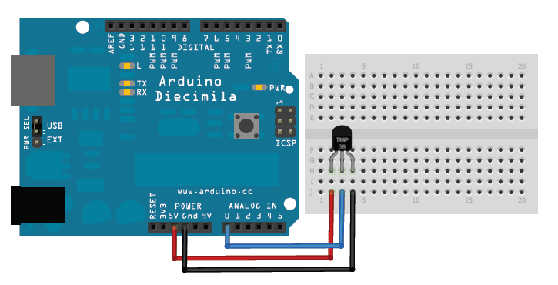

LM35 : If we want to describe it, we can just say that it gives us output voltage which is proportional to Celsius temperature.

**Controlling Body Temperature**

After learning about the modes of heat transfer, we can comment about the controlling of body temperature. Applying the concept of conduction, we can say that if we place a cold wet cloth on our body, it will surely help in decreasing temperature. On the basis of this concept only, we are trying to control our body temperature using peltier device which automatically will switch on if our body temperature goes up beyond a certain value.

**Peltier Device**

Peltier Device uses the [Peltier effect](http://en.wikipedia.org/wiki/Peltier_effect) to create a [heat](http://en.wikipedia.org/wiki/Heat) flux between the junction of two different types of materials. A Peltier cooler, heater, or [thermoelectric](http://en.wikipedia.org/wiki/Thermoelectric) heat pump is a solid-state active [heat pump](http://en.wikipedia.org/wiki/Heat_pump) which transfers heat from one side of the device to the other, with consumption of [electrical energy](http://en.wikipedia.org/wiki/Electrical_energy), depending on the direction of the current. Such an instrument is also called a Peltier device, Peltier heat pump, solid state refrigerator, or thermoelectric cooler (TEC).

It allows cooling below ambient temperature, but unlike other cooling systems that allow this (vapor phase refrigeration), It is less expensive and more compact. Peltier element is solid-state devices with no moving parts; It is extremely reliable and does not require any maintenance.

The typical maximum temperature difference between the hot side and the cold side of a peltier, referred to as delta Tmax, is around 70°C. Although that doesn’t implies that simply adding a peltier element between heatsink and heat source will cause the temperature of the cooled device to drop by 70°C. The specified maximum value of delta T only occurs when the peltier element does not transport any heat - a situation that does not occur in real-life cooling solutions. The actual delta T is a linear function of the power transferred through the thermal element, with negative slope.

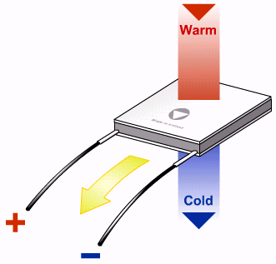

**L293D**

L293D is a dual H-bridge motor driver integrated circuit (IC). Motor drivers act as current amplifiers since they take a low-current control signal and provide a higher-current signal. This higher current signal is used to drive the Peltier.

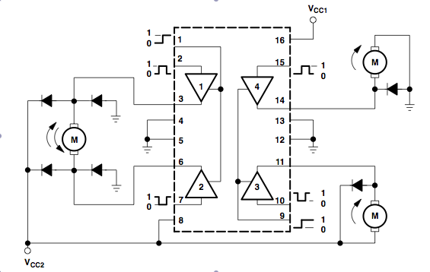

L293D contains two inbuilt H-bridge driver circuits. In its common mode of operation, two mode of Peltier can be driven simultaneously, both in forward and also in reverse direction. The Peltier operations (i.e. current flow in the Peltier device either from high to low or low to high) can be controlled by input logic that is taken from Arduino at pins 2 & 7 and 10 & 15. Input logic 00 or 11 will stop the corresponding Peltier mode. Logic 01 and 10 will rotate it in clockwise and anticlockwise directions respectively.

Enable pins 1 and 9 (corresponding to the two motors) must be high for Peltier to start operating. When an enable input is high, the associated driver gets enabled. As a result, the outputs become active and work in phase with their inputs. Similarly, when the enable input is low, that driver is disabled, and their outputs are off and in the high-impedance state.

**TempPulseBee**

Shown below is the image of our product.

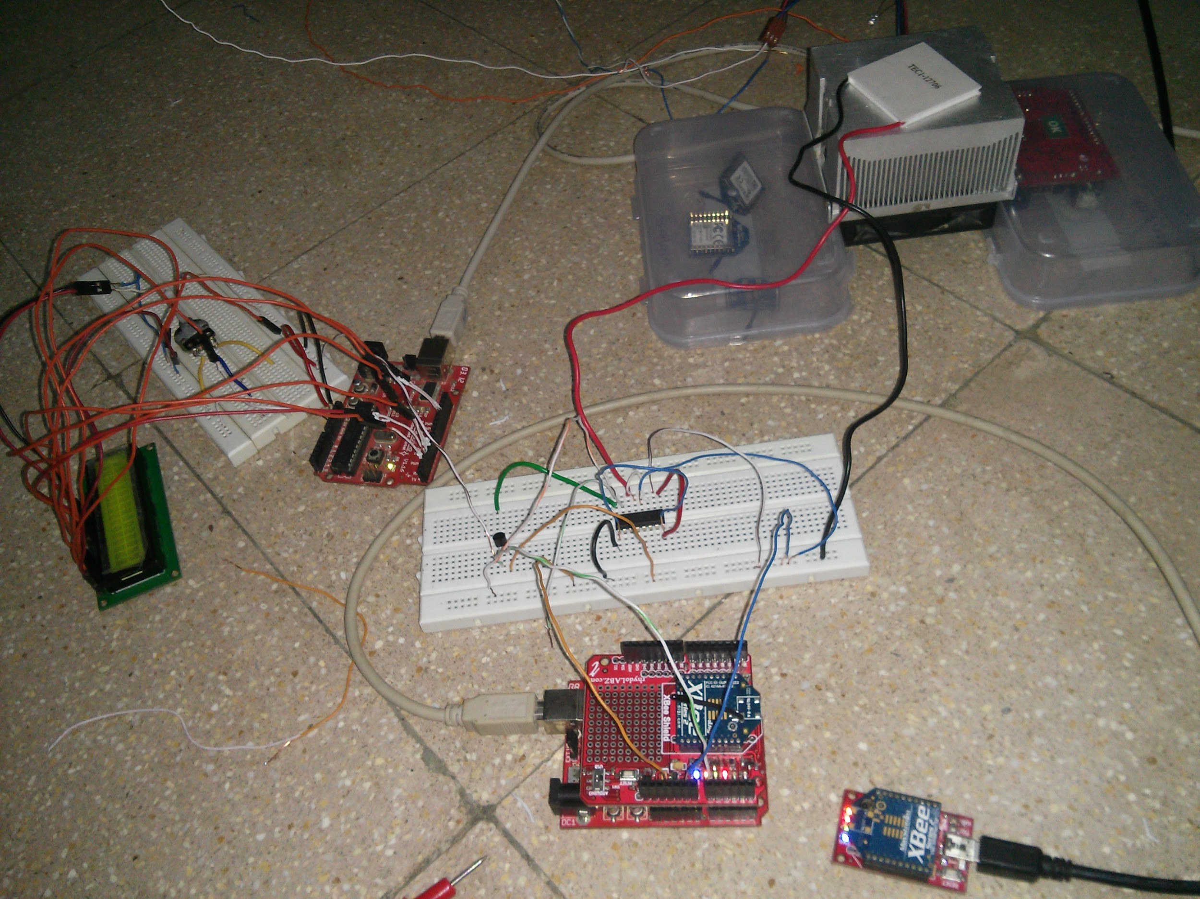

**Acknowledgement**

After working on this project almost throughout this semester, we would like to develop this project further working more on the design aspect making this product more user friendly and cost effective by going out on the field and doing proper testing. Also, we would like to thank Prof. Amit Sengupta and Prof. Asim Banerjee for giving us an opportunity work for TempPulseBee with proper support and guidance.

**Bibliography**

1. [http://s1251.photobucket.com/user/vladimirzec/media/Fiziologija/img387.jpg.htm](http://s1251.photobucket.com/user/vladimirzec/media/Fiziologija/img387.jpg.html)

2. <http://www.youtube.com/watch?v=-_qNTSIJL-I>

3. http://en.wikipedia.org/wiki/Thermoelectric_effect[l](http://s1251.photobucket.com/user/vladimirzec/media/Fiziologija/img387.jpg.html)

4.<http://www.bbc.co.uk/schools/gcsebitesize/science/ocr_gateway/understanding_organisms/staying_in_balancerev2.shtml>

5. http://searchnetworking.techtarget.com/definition/Peltier-effect